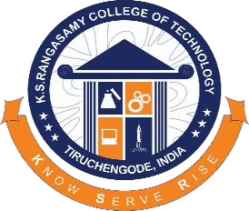
K.S. Rangasamy College of Technology
(Autonomous)

Department of Computer Science and Engineering
Student Participation

AWS LAMBDA:POWERING SERVERLESS COMPUTING
Place: K.S.Rangasamy College of Technology
Date: 19.02.2026
Students Attended:
II YEAR CSE A
Session Handled By: Amirtha Anitha R

Outcome of the Event:
Students of II Year CSE – A attended the session on “AWS Lambda: Powering Serverless Computing” conducted as part of the AWS Cloud Initiative Program organized by the Department of Computer Science and Engineering at K. S. Rangasamy College of Technology.
The session was presented by Ms. Amirtha Aniha R, a student from the Department of Computer Science and Engineering. The session introduced students to the concept of serverless computing and how Amazon Web Services (AWS) enables developers to build and run applications without managing servers.
Students were introduced to the working principles of AWS Lambda, including how functions are triggered by events, automatic scaling, and pay-as-you-use pricing. The session also explained how Lambda integrates with other AWS services to build scalable and efficient cloud applications.
The presentation highlighted the key advantages of AWS Lambda such as reduced infrastructure management, automatic scaling, cost efficiency, faster development cycles, and seamless integration with cloud services. Students also gained insights into real-world applications of serverless architecture in modern software development.
To make the session more engaging and interactive, a Kahoot quiz activity was conducted to test the students’ understanding of the concepts discussed. The activity created an enthusiastic learning environment and helped reinforce key ideas about serverless computing and AWS technologies.
The session provided valuable exposure to cloud computing technologies and helped students understand how modern applications are developed using serverless architecture.
Glimpses :
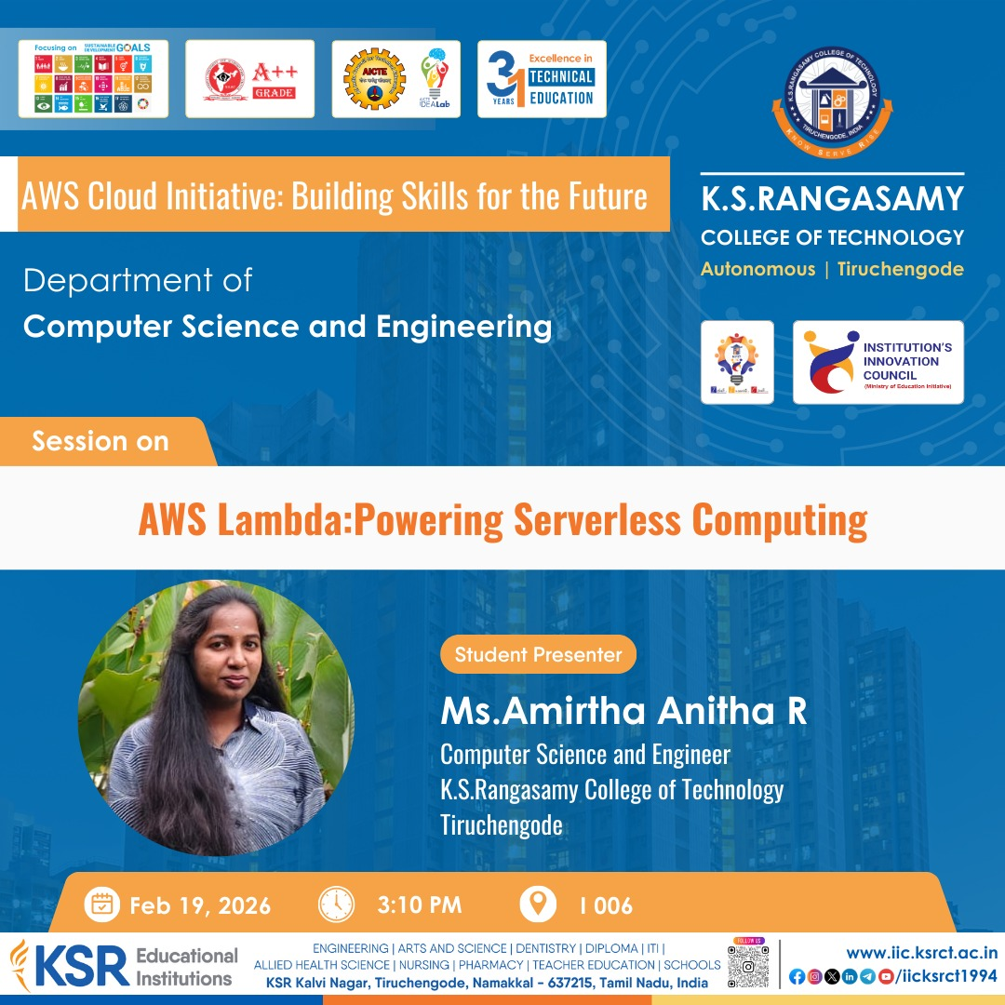
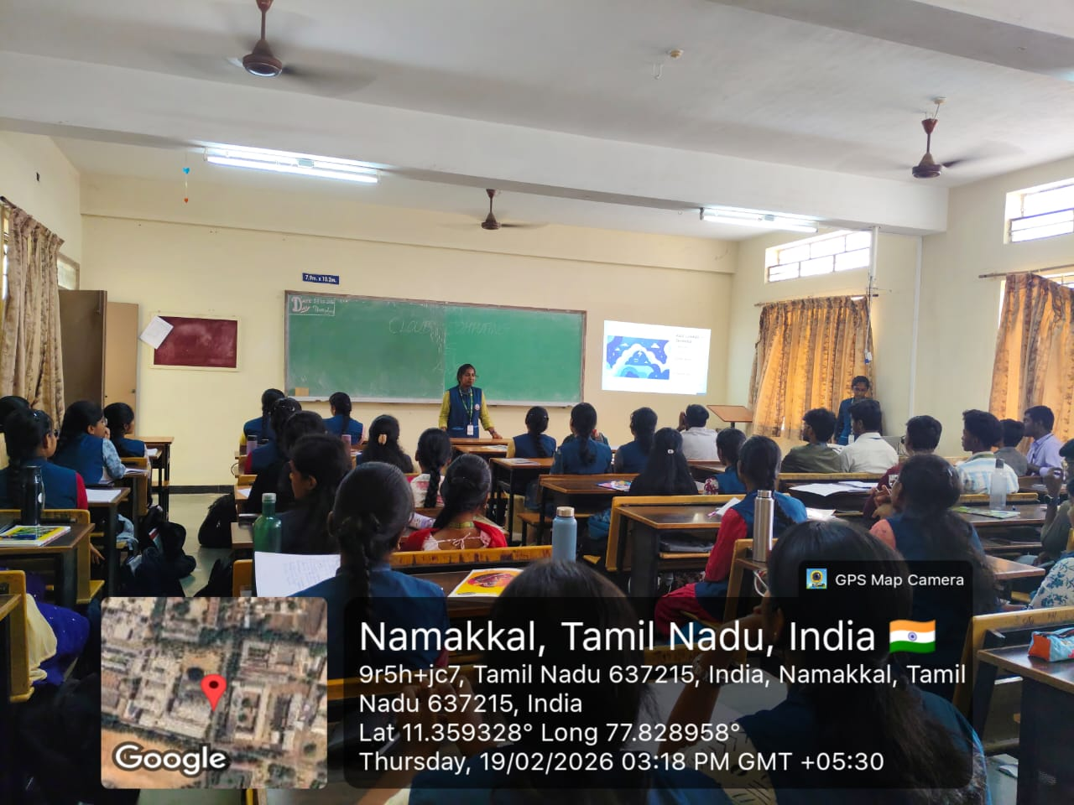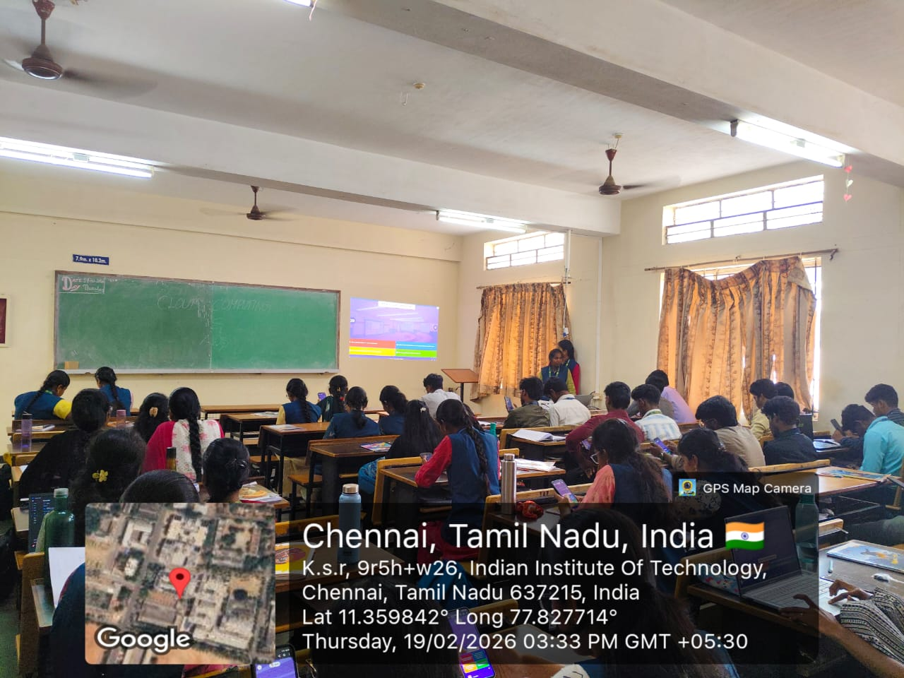

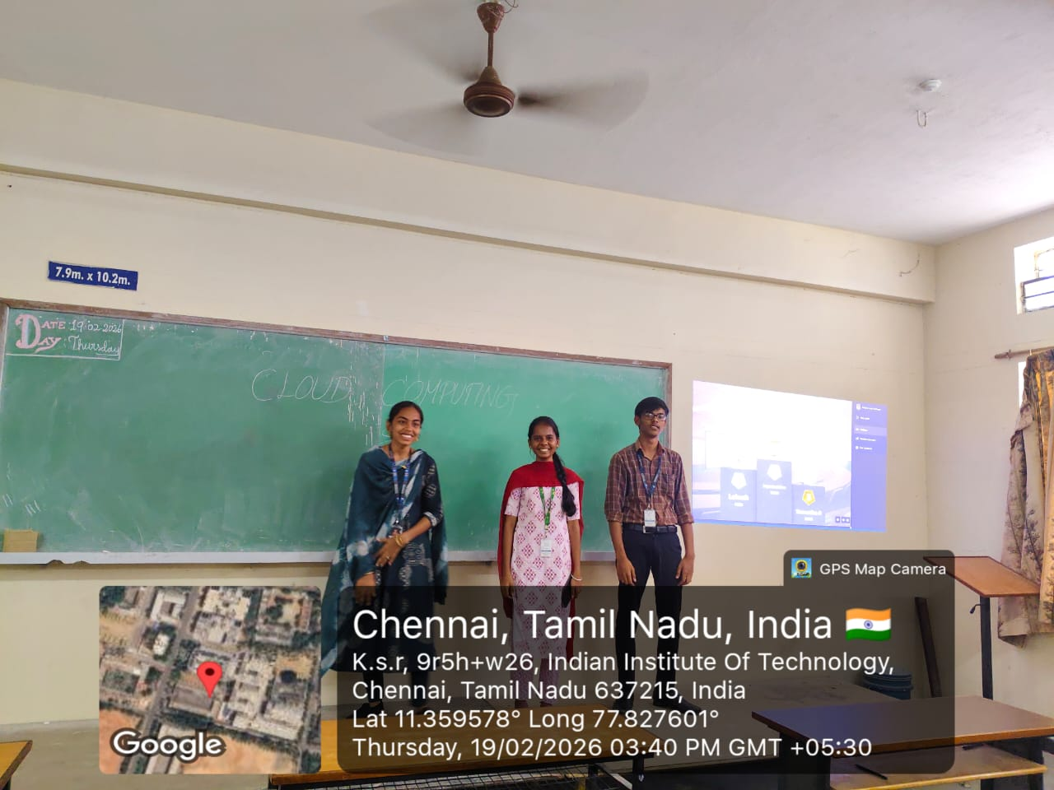
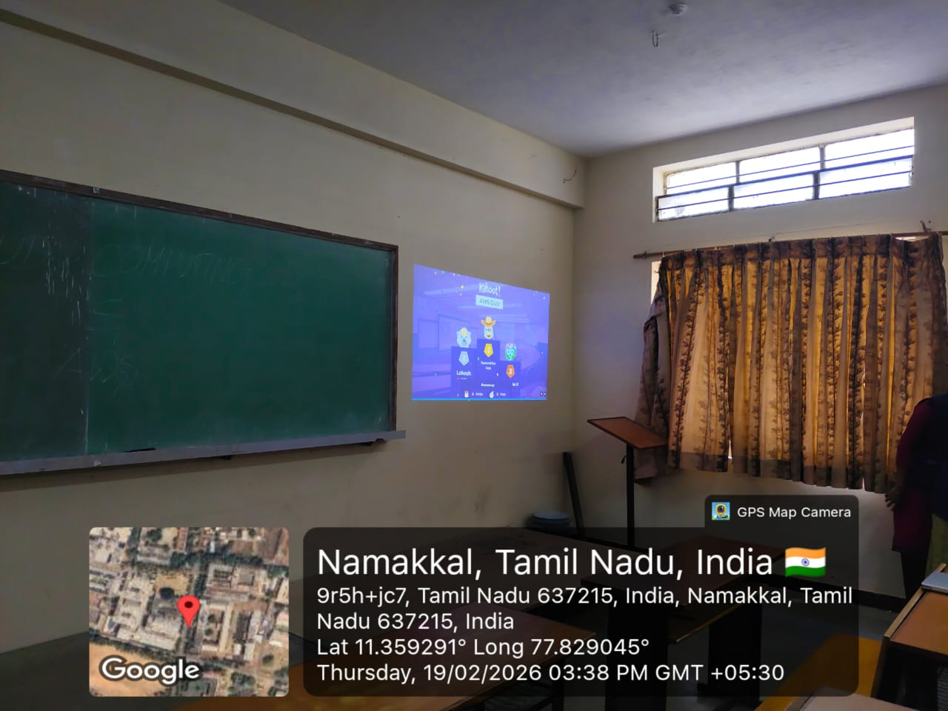

Prepared By HOD/CSE

